# High Impact Skills Development Program

# in Artificial Intelligence, Data Science, and Block chain

# Project Title : Data Mining Project

# Submitted by : Parvez Alam

# Submitted to : Eid Muhammad

**Program : Artificial Intelligence, Data Science**

# Date : 23-08-2023

# Section : 03

# 

**Beginner Queries.**

* **Define meta data in mysql workbench**
* **What is the distribution of order values across all customers in the dataset?**
* **How many unique products has each customer purchased?**
* **Which customers have only made a single purchase from the company?**
* **Which products are most commonly purchased together by customers in the dataset?**

# 

**Q#01**

**Define meta data in mysql workbench?**

**(Ans)**

Metadata in MySQL Workbench refers to the information about the structure and properties of a database and its objects. This includes details about tables, columns, indexes, relationships, data types, and more. Metadata helps in understanding the organization of the database and its components, aiding in database management, querying, and maintenance tasks.

# Q#02

**What is the distribution of order values across all customers in the dataset?**

**(Ans)**

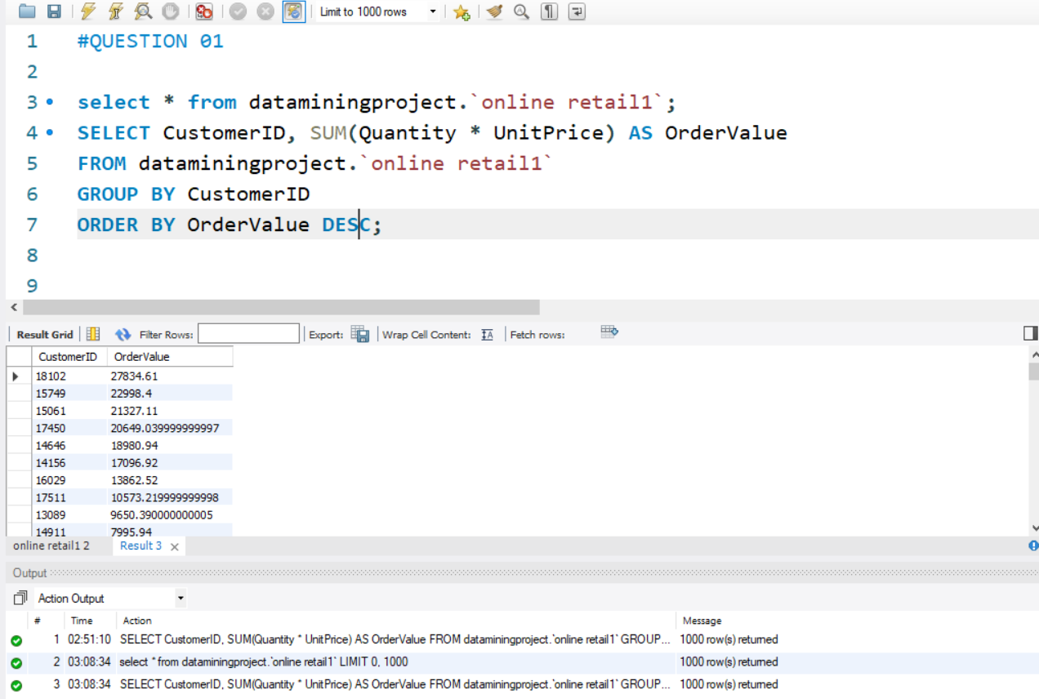

**Q#03**

**How many unique products has each customer purchased?**

**(Ans)**

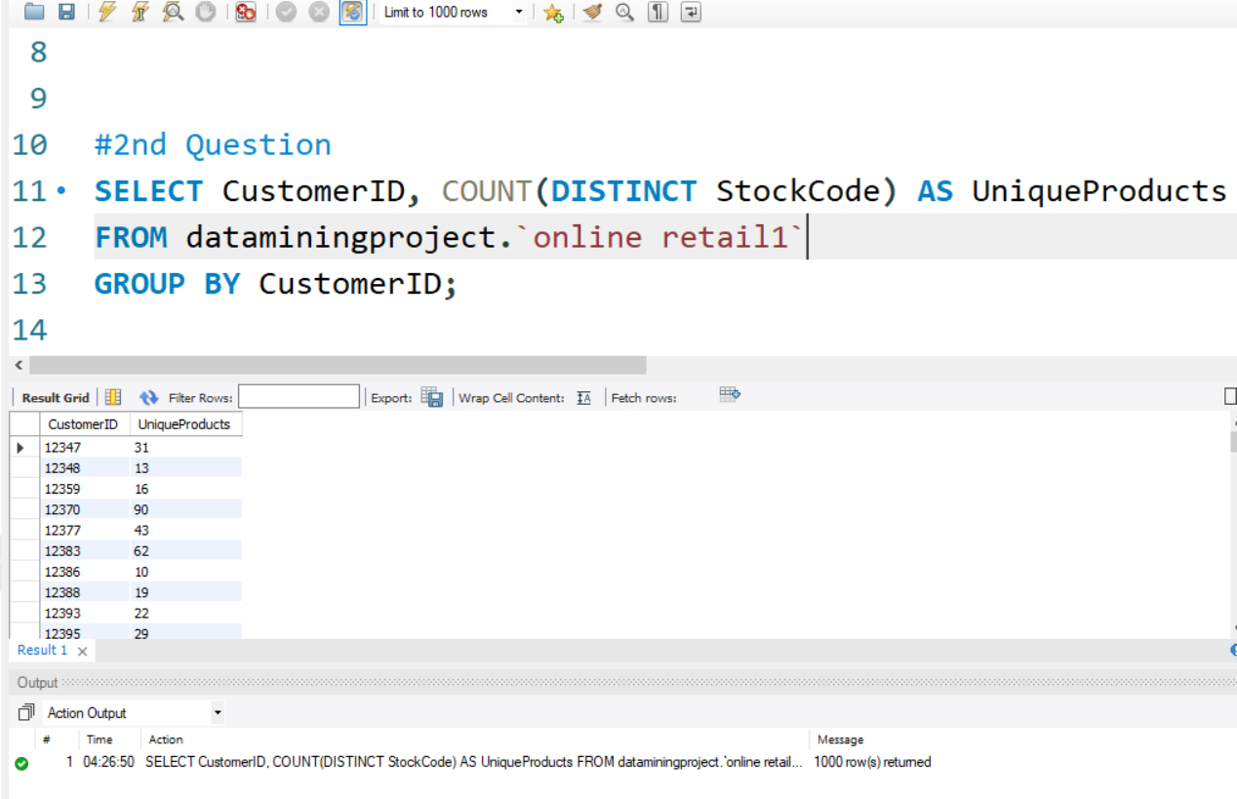

**Q#04**

**Which customers have only made a single purchase from the company?**

**(Ans)**

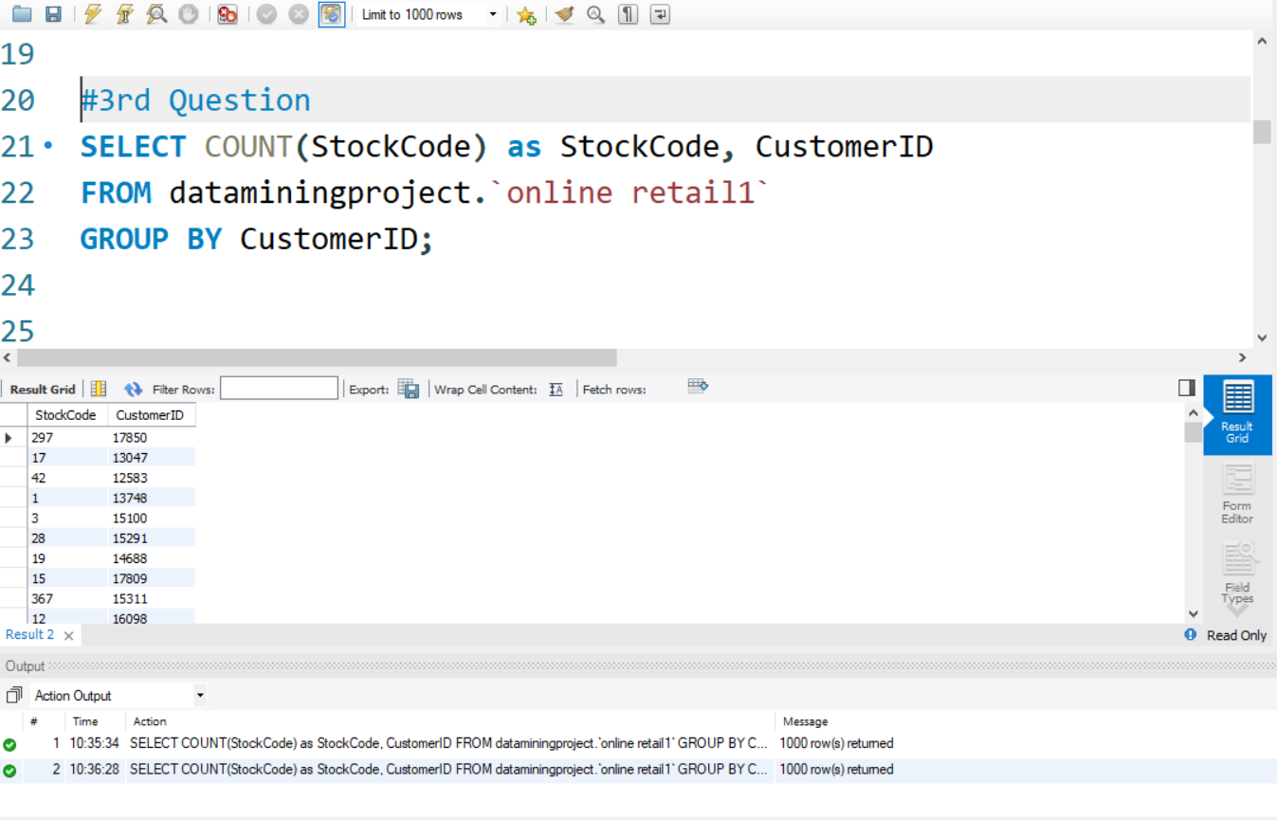

**Q#05**

**Which products are most commonly purchased together by customers in the dataset?**

**(Ans)**

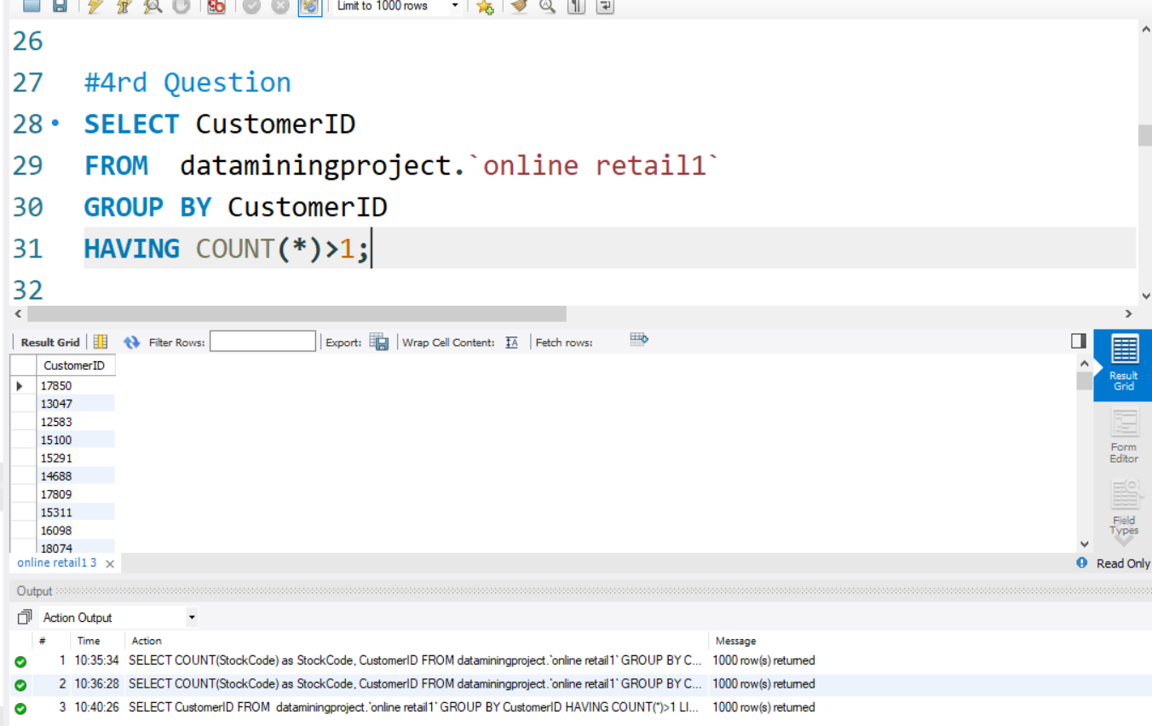

The End